Headache
Dizziness
Speech/Swallowing
Nausea/Vomiting
Tinnitus
Blurred vision
Faints/Drop attacks
Weakness:
[dropping/things/buttons/lids]

Cough/Sneeze
Perineal anaesthesia
Bladder retention/Incontinence
Bowel Incontinence
Bilateral pins & needles
Balance
Heaviness in legs
Weakness:
[tripping/giving way]

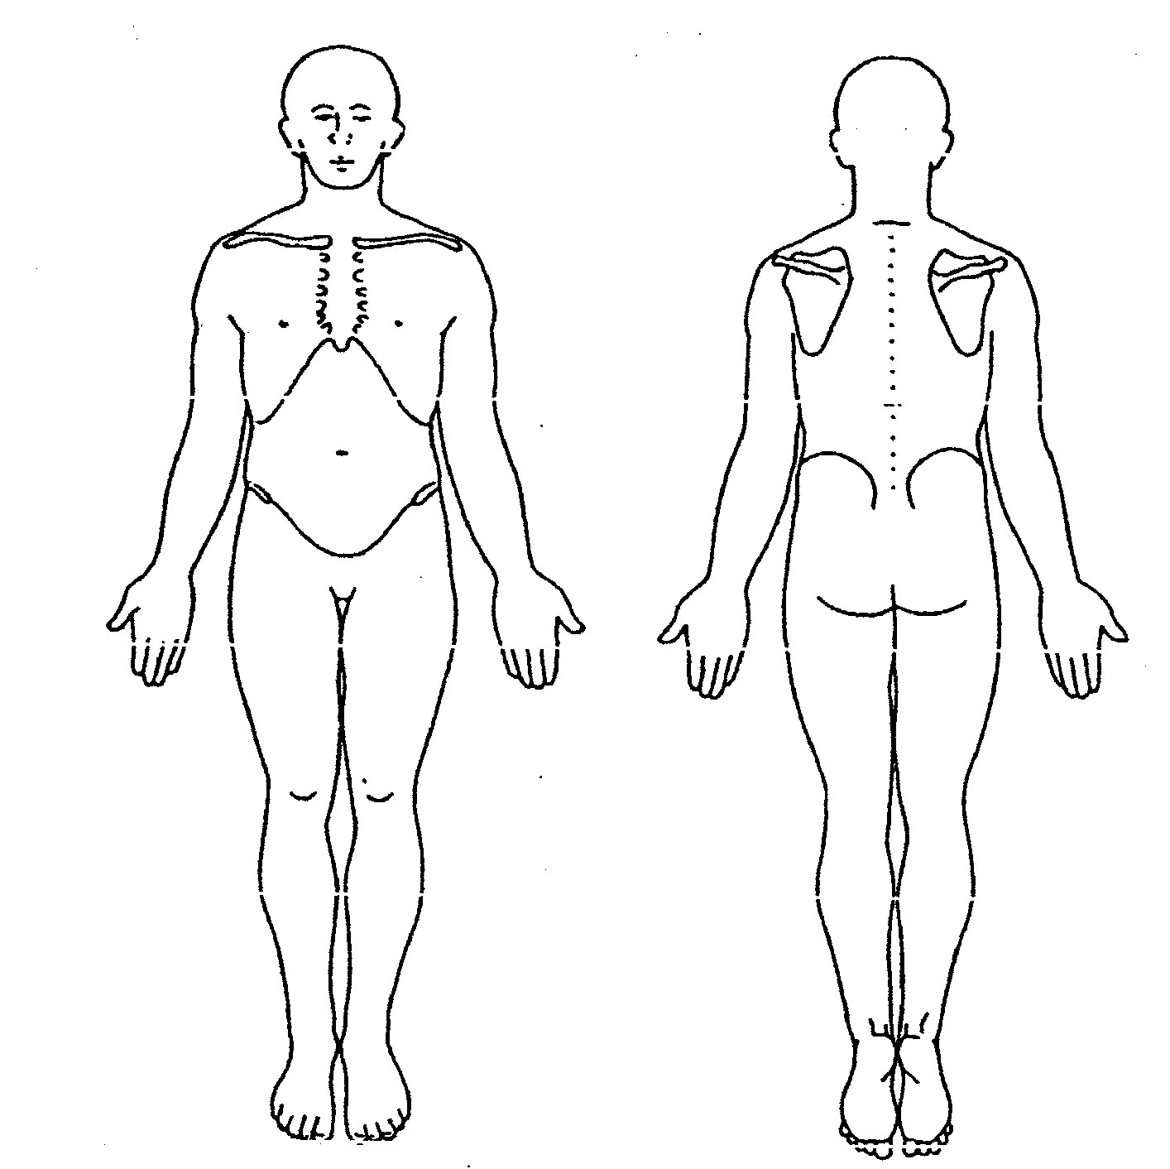

Night

AM

Day

PM

Functional demo

0
10

Aggravated | Eased

Signed ………………………………………………………………. Date ………………………………………..

Name (print) …………………………………………… Qualifications ………………………………………..

HPC

X-ray
MRI
USS

General health
Weight loss
Diabetes
Epilepsy
Cancer
RA
Osteoporosis
CVS
BP
Fractures
Surgery
Other injuries
Pregnancy

Steroids
Anticoagulant therapy
Allergies

Previous treatment

PMH

DH

SH

Patient expectations

Signed ………………………………………………………………. Date ………………………………………..

Name (print) …………………………………………… Qualifications ………………………………………..
Observation

Range of Movement

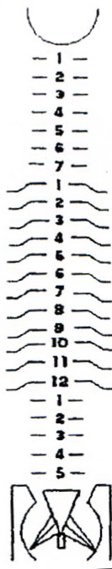

Joint

Muscle

Nerve [signs or mobility]

Function

Signed ………………………………………………………………. Date ………………………………………..

Name (print) …………………………………………… Qualifications ………………………………………..
Date | Clinical Impression
 | Subjective marker
 | Objective marker
 | Outcome measures
 | Problems
 | Goals |  |  |  |  | Achieved | Initials
Treatment Plan |  |  | Agreed with patient |  | ◻

Signed ………………………………………………………………. Date ………………………………………..

Name (print) …………………………………………… Qualifications ………………………………………..

Consent to share information with others (if appropriate) ………………………………………………………

